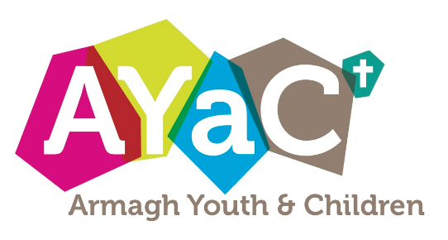

**Please return your group booking and payment to Mr David Brown, Church House, 46 Abbey Street, Armagh BT 61 7DZ by Friday 28th September.**

Please know a very warm invitation to our Diocesan Youth Weekend. Alongside young people of secondary school age from other parishes in our Diocese, you will enjoy games at Murlough House, outdoor activities at Greenhill, YMCA, engaging talks from the Bible and generally a very fun filled weekend! This is an opportunity not to be missed!

**Armagh Diocesan**

**Youth Weekend**

**Murlough House, Dundrum.**

**Friday, 12th – Sun 14th October**

✂️

**For further info. please contact David Brown (07557 655860 / doycarmagh@gmail.com)**

**Payment Details** :- Cost £60. Includes activities and all meals. Payment welcome in full or by instalments. Cheques payable to ‘Diocese of Armagh Youth Grant Account’ please. Booking deadline Friday 28th Sept.

**CHECK LIST :-**

* sleeping bag & pillow
* spare clothing (warm)
* spare shoes
* waterproofs
* wash kit
* towel
* torch
* spending money
* bible, notebook & pen
* snacks & drinks

**Travel Details** :- Lifts are available from regional collection points which will be determined when bookings are received. Further details will be shared with Group Leaders in due course.

Name : _________________________________________________________

Address : _______________________________________________________

_______________________________________________________________

D.O.B : ___________________ Age at AYAC Weekend :_________________

Church / Youth Group : ____________________________________________

Any Medical Conditions or Medication that we should know about?

_______________________________________________________________

Any Dietary Requirements ? _______________________________________

I confirm that I have given my consent for ____________________________ to attend the AYAC Weekend and to take part in all planned activities, including those offered at Greenhill YMCA. In the event that my son / daughter / ward being taken ill or injured so that surgery or serum injection becomes necessary, I hereby authorise the leader in charge to sign on my behalf any written forms of consent where necessary. YES NO

I give my consent for my son/ daughter / ward’s photograph to be taken and shared for AYAC Publicity purposes. YES  NO 

Parent / Guardian’s Signature : _____________________________________

Contact Telephone Number : _______________________________________

Group Leader’s Name : ___________________________________________

**AYAC WEEKEND 2018**

12th – 14th October @ Murlough House, Dundrum, Co. Down

